3 February 2019; updated 6 June 2019

Request for Proposal and Quotation: Creative Freelancer/Consultant Framework

INSTRUCTIONS TO BIDDERS

Request for Proposal Pack
The RFP pack for this Service is comprised of:

- These Instructions to Bidders
- Terms of Tendering
- The Request for Proposal, outline service requirements
- ActionAid UK Standard Supplier Contract Terms
- New Supplier Pre-Qualification Questionnaire
Introduction to ActionAid UK
ActionAid is a leading international charity working in over 45 countries. We work with the poorest women and girls in the world, changing their lives for good.

ActionAid UK (AAUK) raises money to support ActionAid’s programme work to transform communities; we influence policy to change the systems and structures that keep people poor; we carry out research and put pressure on governments and key decision makers to effect global change.

Further details can be found on our website: www.actionaid.org.uk

Background to Services

The objective of this RFP is to establish a Framework of diverse, highly skilled creative consultants/freelancers able to support ActionAid UK’s work between 2019 and 2022.

As prospective funding becomes available, Terms of Reference, outlining each item of work required, will be sent to each consultant in the framework, depending upon their stated skills and expertise, for an opportunity to bid on the stated position. These bidding opportunities will be short-term, perhaps as little as 3-4 days, and ActionAid will make a selection at that time. In contracting for this work, we will use the fee rate range determined by Contracts and Procurement’s review of each consultant/freelancer’s fee rate as part of our final agreement. In this way, ActionAid UK will likely have a turnaround from initial bid to putting a consultant under contract in 10 working days or less. We expect to tender both planned pieces of work (in advance) and short-term pieces of work through the Framework.

Please note that submission to this Request for Proposal indicates your willingness to become part of this Framework agreement and is not a guarantee of work.

Evaluation Process and Award Criteria

Pre-Qualification: All bidders must first pass minimum standards of financial viability, probity, and legal compliance. This will be assessed based on independent credit checks, sanctions screening, and information provided in the New Supplier Pre-Qualification Questionnaire (PQQ) which must be returned together with proposals. We may request evidence of any information set out in the PQQ document and reserve the right to reject any proposals where evidence cannot be provided.

Consultant Specification

Please see RFP for requirements for each consultant or freelancer position. Potential Bidders may respond to one or more Lots, but must designate the specific Lot, Subgroup (if applicable), and specific position to which they are replying. Failure to follow these instructions will result in either a delay in the review of your submission, or full rejection of your submission, if we cannot determine the exact positions for which you are replying.

Evaluation Methodology: The evaluation of each proposal will be based upon the following criteria:

Criteria | Weighting - %
Price | 20%
Depth of Overall Experience | 40%
Expertise | 40%

Shortlisting and Interviews
Bidders who are able to meet ALL our Requirements may be invited to interview with a panel of ActionAid stakeholders; this is optional to the requesting department. The purpose of the interview will be to answer any questions in relation to the proposed services and address any concerns which the panel may have arising from the proposals.

In the event that more than three bidders are able to meet all our Requirements, we reserve the right to invite no more than the three highest scoring suppliers to interview. We may invite less than three suppliers if the difference in scores is considerable; this is to avoid wasting the time of suppliers who are highly unlikely to be successful irrespective of the outcome of an interview.

After interviews, the initial proposal scores will be re-visited and adjusted in light of relevant information received at interview.

Contract
The inclusion into the Consultancy Pool will last for 3 years, until 28 February 2022. Any contract awarded through the use of the Consultancy Pool will be on a non-exclusive basis. A copy of AAUK’s standard supplier contract terms is attached.

Timetable
The key indicative dates for this tender process are set out below. AAUK reserves the right to modify this timetable at any time. Any changes to the timetable will be communicated to all bidders who have expressed an interest in delivering the Services

Process step | Date
RFP & Tender documents distributed to vendors | 04 February2019
Deadline for RFP responses, by 23:59 on stated dates | 28 February 2019, and then every two months until 30 June; quarterly thereafter:  30 April 2019  30 June 2019  30 September 2019  31 December 2019  31 March 2020  30 June 2020  30 September 2020  31 December 2020  31 March 2021  30 June 2021  30 September 2021  31 December 2021  31 March 2022
Selection of vendor | Within 2-3 weeks after stated deadline
Inclusion in Creative Consultant/Freelancer Pool | Within 4-5 weeks after stated deadline

Any questions concerning aspects of the RFP’s requirements should be directed to

Rosalind Animashaun | rosalind.animashaun@actionaid.org
.
Submitting your Proposal
Bidders should complete and return a copy of the New Supplier Pre-Qualification Questionnaire and completed proposal in response to the RFP to the PoC by the Deadline for Proposal Submissions.

Proposals should be clearly marked as: Request for Proposal and Quotation: Creative Freelancer/Consultant Framework

Proposals will be accepted before the Deadline, but no Proposal will be considered if received after the Deadline unless there is evidence that the Proposal was delivered (such as email delivery or read receipt) or other extenuating circumstances, which it shall be at AAUK’s absolute discretion to reject.

Point of Contact (PoC), Expressions of Interest, and RFP Process Queries

The point of contact (PoC) for this tender process shall be:

Katherine Griffis, Contracts and Procurement Manager

The PoC can be contacted at the following email address:

Commercial.uk@actionaid.org

Please submit expressions of interest (EoI) to the PoC. You are not required to submit an EoI as a pre-requisite to submitting a proposal, however, submitting an EoI will ensure that we are able to notify you of any changes to these documents, the process, or our Requirements.

In addition, any queries related to this process and our Requirements should be addressed to the PoC. The deadline for the receipt of any clarification questions is 5 days before the quarterly deadline.

We look forward to hearing from you.

Best wishes,

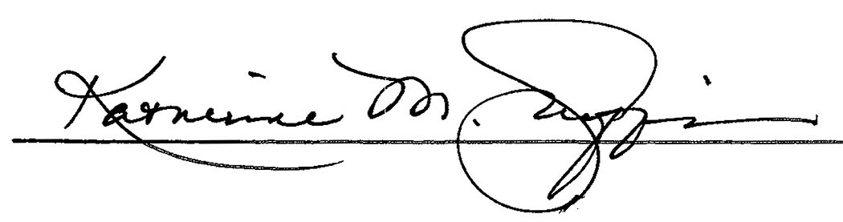
Katherine Griffis
Contracts and Procurement Manager

